Assignment 1
Group forming
Abstract Domain Model
The purpose of this assignment is to
- Form groups, between 1 and 4 members
- Select project case
- Set up the initial git repository
- Create an abstract domain model of the chosen project case.
All assignments will be handed in through git, and you must follow the structure described in the assignments.

Domain model
You have been given various documents describing the project cases. Based on this information create a domain model. It must be exported to a readable format, e.g. png or svg. Make sure everything is readable, and not blurry!

Project setup
You will develop the project with .NET and C#.
The first step is to create a new solution to set up your project. Then put it under git version control, put it on GitHub, and share it with your group members.
- New solution
Create a new empty .NET solution. Give it a name (based on your project case) and create a git repository. The following screenshot is from Rider (spring 2023), but you may use whichever IDE you prefer. However, the solution structure must follow the guidelines given throughout the assignments, as a large part of your architecture comes from this structure.
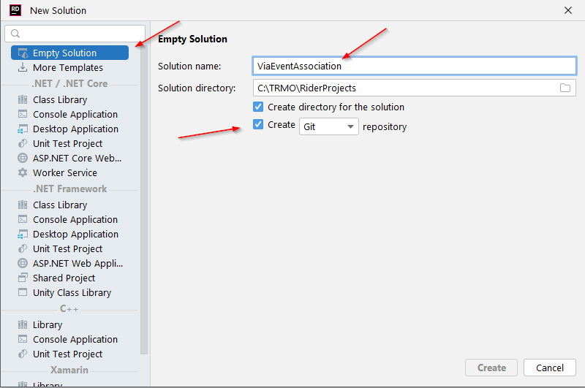
Figure 1 Create new solution
- Create a solution folder
We are going to organize the project into different solution folders. These are ”virtual folders”, they only exist inside the IDE. Though, you should strive for a physical project folder structure, which matches the solution folders. More on this later.
First, create a new solution folder, call it ”Documentation”:
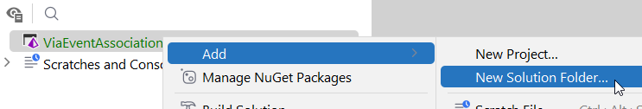
Figure 2 Create solution folder
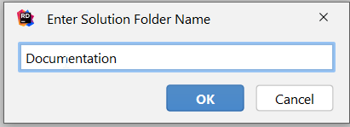
Figure 3 Name solution folder
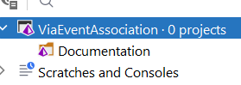
Figure 4 Result

This solution folder should contain various pieces of documentation throughout the project:
- Abstract domain model
- Concrete domain model
- Completed features
- etc
Inside this solution folder, you might create more solution folders, as needed, per each assignment.

4) Branches
You may create whatever branches you need, but the main branch should be kept up to date, when you reach an assignment deadline.

5) Create md file
Create a new markdown file:
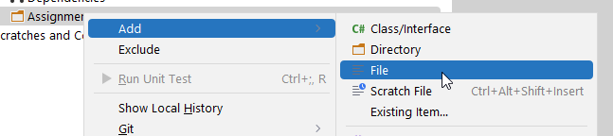
And then call it:
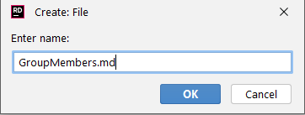
In this file, you just put the names and student numbers of the group members.

Your task
1) Group
Create a markdown file containing student numbers and names of your group members.
You are recommended to work in groups, it’s a large project, the size is intended for group work. But too large groups, and you will not be working enough, and learn less.
Some may decide to go solo, that is allowed, but you will either have a lot to do, or not get as far, and potentially miss out on learning opportunities.

2) Abstract Domain Model
Based on the provided documentation (case description and use cases), create a domain model of your project case. I call it “abstract”, because we will see another kind of domain model in assignment 2. I will call this a “concrete domain model”.
You may use any diagram tool. I recommend draw.io (diagrams.net). Here you can collaborate, the file can be saved on google drive and shared. At the bottom, you can have multiple tabs, so all future diagrams can be put in the same file. It exports nicely to both png or svg. If you do png, you may have to increase the zoom level to e.g. 300%, it will increase the DPI, making the diagram less blurry.
Make sure the diagram is readable!
Please make sure the diagram is readable!!

- Feedback on the project?
Any feedback you encounter, put this in a markdown file, or send me an email, or just come talk to me.
- Is something in the project descriptions unclear?
- Is information missing?
- Are use case scenarios missing, unclear, wrong?
- Anything else at all?
Any feedback is valuable.

- Handing in
The assignment is handed in on itslearning, you just put in a link to your domain model diagram.
Deadline will be posted on itslearning.

